Fiona Shavilof

Sequence Type | Number of Sequences (n) | N50 | Predicted Genome Length (sum)
Unitigs | 316 | 110,148 | 3,906,726 bp
Contigs | 237 | 126,675 | 3,970,994 bp
Scaffolds | 195 | 141,117 | 3,973,339 bp

- abyss-pe name=assembly k=96 B=2G in='Fiona_1.fastq.gz Fiona_2.fastq.gz'
Name | Function
Abyss-pe name | This helps run ABySS by managing all the steps necessary in forming the unitigs, contigs, and scaffolds.
k | k-mer size, short DNA sequences that are used to construct th assembly
B | How much memory your allowing ABySS to use.

- Hybrid genome assembly combines short and long read sequencing to create more of an accurate and complete genome assembly. People might want to use hybrid assembly as it can provide a better genome assembly as it uses both short and long reads to help reduce fragmentation in the sequence.
The code to use to modify SPAdes for a hybrid assembly with Nanopore reads could be
spades.py \ -1 Fiona_1.fastq \ -2 Fiona_2.fastq \ --nanopore nanopore_reads.fastq \ -o hybrid_spades_output

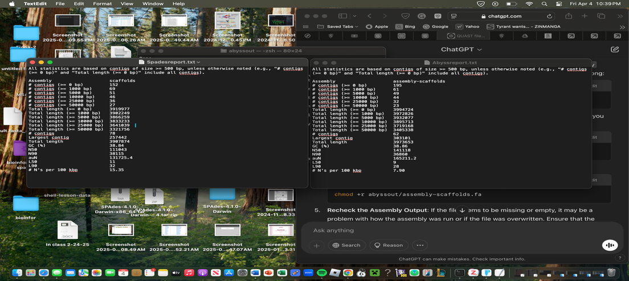

- Based on the output, I believe AbySS is the best because it contained fewer and longer contigs, had a higher value N50 and a lower number of N’s per 100kbp. This will generate a more accurate results as it will create a less fragmented genome which will be better for annotation.
- Barrnap can be used to locate ribosomal RNA genes, such as the 16s rRNA gene in a completed genome sequence. The 16S rRNA sequence can be extracted by running Barrnap on command line. It will create a fasta file where we can use NCBI to identify what species we have. Using the 16S sequence might not be ideal because it could be hard to differentiate between species that have almost an identical 16S sequence.
- The species I have is Acinetobacter baumannii. I decided to use A. pittii & A. nosocomialis as my two related genome of my species.
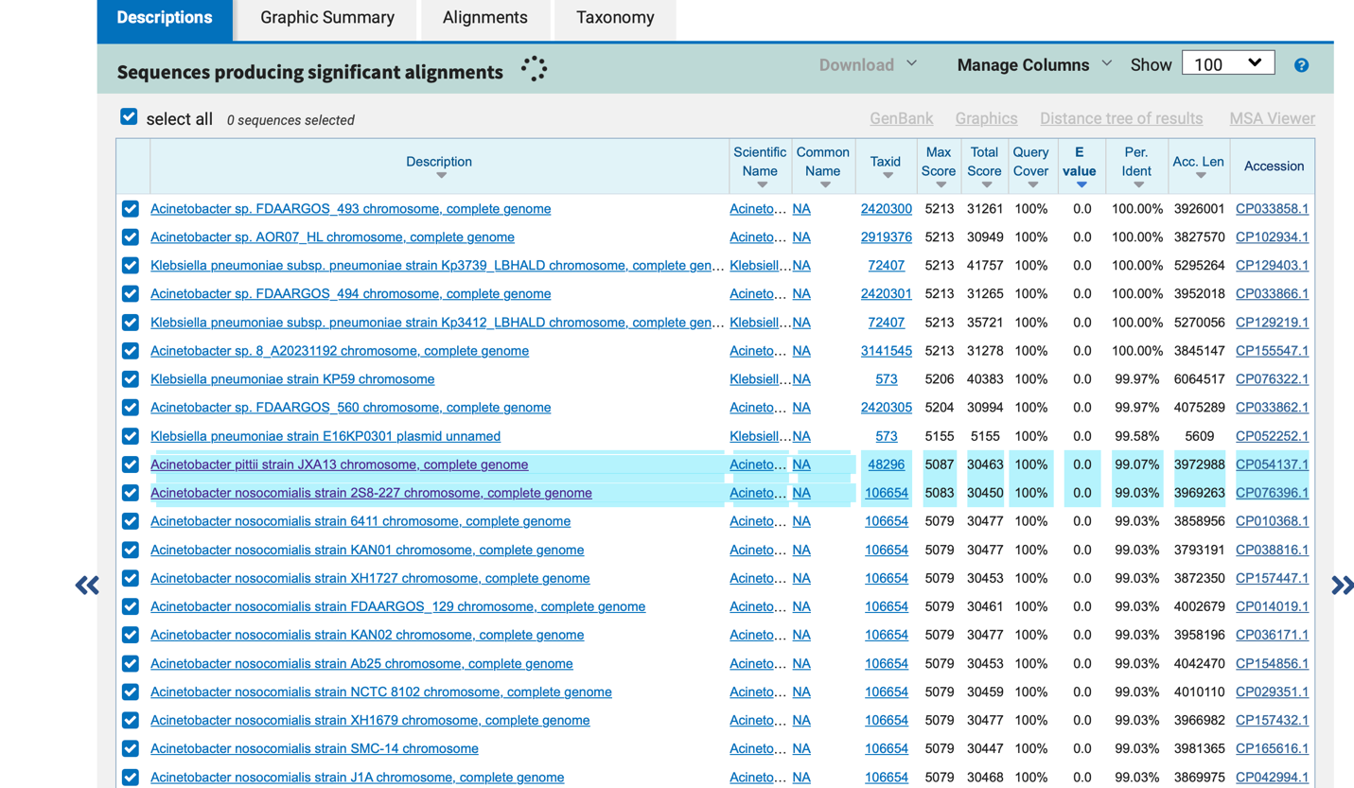
- The process of locating and analyzing functional components from a genome sequence is known as genome annotation. Genome annotation includes a vast number of features such as, identifying genes, regulatory elements, and assigning function. The ability to find and examine these traits can provide many benefits such as, getting a better understanding of the genome itself, which helps allow scientist to better correlate specific genes to their functions as well as using this process to help create medicine by understanding and annotating the human genome to see how it responds to specific drugs.

Gene | Tool | Location (Start-End) | Strand | Product Description | Notes
recA | DFAST | 57807–58856 | Reverse (-) | Recombinase RecA | Similar to WP_002115680.1 (96.7% identity)
gyrA | DFAST | 93006–95720 | Forward (+) | DNA gyrase subunit A | Similar to WP_014207410.1 (95.1% identity)
rpsB | DFAST | 75286–76038 | Reverse (-) | 30S ribosomal protein S2 | Similar to WP_002118204.1 (93.6% identity)

Gene | Tool | Location  (Start-End) | Strand | Product Description | Notes
recA | Prokka | 43141-44190 | Forward (+) | Protein RecA | similar to AA sequence:UniProtKB:P65977
gyrA | Prokka | 36398-38866 | Forward (+) | DNA gyrase subunit A | similar to AA sequence:UniProtKB:P0AES6
rpsB | Prokka | 73494-72742 | Reverse (-) | 30s ribosomal protein S2 | similar to AA sequence:UniProtKB:P0A7V0
When using both tools, they generated mostly the same information. With Prokka it told the gene name, the location, strand, product description, inference, locus tag, and translated protein sequences. DFAST also generated the same information above, but it provided more details such as pathways, and COG categories.

Query Genome | Reference Genome | ANI(%) | Matching Fragments | Total Fragments
Spadesoutput/scaffolds.fasta | Nosocomialis.fasta | 92.08% | 1041 | 1263
Spadesoutput/scaffolds.fasta | Pitti.fasta | 89.26% | 1046 | 1263

The first column shows the genomes that is being compared to, the reference genomes are the ones being compared. The ANI shows the percentage of how identical the nucleotides are between the query and reference genome. Matching fragments shows how many genome fragments are similar to the query genome and the total fragments are the amount of number used from the query genome to compare the results. A percentage of 95 or higher indicates the species are the same. Since I used two different species from the same genus, a value of 92.08% and 89.26% makes sense as they aren’t the same, but closely related to A. baumannii.

